**Bending of Belmadi**[1]

For Classroom Discussion only

“We have completed the project and submitted our bills. Your officers are finding only excuses for not passing the bills for payment. Please use your good offices so that they stop this harassment. You know lot of our money is tied up in this project. The bridge is absolutely safe and the stress tests prove it without doubt” said Sebastian Sinha. He came to plead his case with Surendra Belmadi who is the chairman of the Bridge Construction Corporation of India (BCCI). Even though Belmadi is non-executive chairman of the corporation, he being a political appointee, wields substantial influence in the organization. Sebastian is referring to a bridge constructed on a major river in South India. He is the managing director of Krishna-Kaveri Infrastructure Company Ltd. (KKICL), which has executed the project. KKICL fought bitterly for the project and had to bid very low in order to get the L1 (lowest bidder) status. Sebastian and Surendra knew each other for many years and go back to their student days in the Doon School.

“Sebby (that was how he was known in Doon School), our corporation is known for timely payments to the contractors. While I don’t want to influence our technical people, I will see what is holding this up” replied Belmadi.

He called for a meeting of the Senior Engineer-in-Chief in the afternoon to enquire the status of these bills. The Senior EnC explained that there are some issues with respect to the quality control, especially with respect to the stress tests and Dhanvin, the Chief Engineer responsible for quality control will be able to explain better. They arranged for a meeting with Dhanvin on the following day.

They had all met the next day and Dhanvin explained that they are in the process of starting the stress tests. He explained that the testing required a number of “deflectometers” and these are being obtained from different branch offices. He also said that the testing can be started within a week since they managed to obtain sufficient number of deflectometers over the past month. Belmadi said, “I thought the testing is done based on taking core samples from the structure and analysing the cores. What is all this about deflectometers”? He was suspicious that this is a ruse to unnecessarily delay the payment. Dhanvin explained the entire process of testing, explaining that this is the standard way of obtaining the stress values. The process, as explained by Dhanvin is presented in the Appendix.

Belmadi commented that these stress values, whichever way obtained, are only samples and they are, like all samples, are unreliable. Dhanvin corrected saying that Belmadi probably meant “uncertainty associated with the sample” and not really meant “unreliable”.

Belmadi insisted that, whichever language is used (unreliable vs. uncertainty) the office will have to provide enough margin to account for the sampling. He said, “You know, I was talking to my neighbours daughter last night. She just completed her MBA from one of the renowned institutions in the country. She was mentioning to me that this issue can be resolved by what is called ‘hypothesis testing’. She was suggesting that we should test something called null hypothesis by stating that the mean is greater than what was specified in the tender documents and compare it ____________________________

with the sample mean. If the sample mean is greater than what was specified, then we can go ahead and release the money to Krishna-Kaveri. She also said something about accepting the hypothesis even if the sample mean is marginally less than what was specified. She was talking about something like one-sided test. I don’t know if being one-sided is good or bad. I did not understand most of it anyway, but I am sure you know how to do this so called hypothesis test. What was the stress value specified in our tender”?

Dhanvin said that he knows all about the one-sided hypothesis test and that the specified value for the safety of commuters was 87 kips (A kip is an Imperial unit of force, equals 1000 pounds-force, used primarily by American architects and engineers to measure engineering loads. It is occasionally also considered a unit of weight, equal to 1000 pounds, i.e., one half of a short ton).

1. **Set up a one sided null hypothesis and alternate hypothesis statement.**

Solution: Choice of null hypothesis:

There are certainly 2 choices of hypothesis:

|  |  |  |
| --- | --- | --- |
| **Null Hypothesis choice 1** | | |
|  | **Actual Bridge limit >= 87 kips** | **Actual Bridge limit < 87 kips** |
| **Conclude Bridge limit >= 87 kips** | Implication: Open the bridge and it’s a good decision | **Type 2 error Implication: Inaugurate bridge. After few days it collapses** |
| **Conclude Bridge limit < 87 kips** | Type 1 error Implication: Ask contractor to strengthen more | Implication: Don't open the bridge good decision |

|  |  |  |
| --- | --- | --- |
| **Null Hypothesis choice 2** | | |
|  | **Actual Bridge limit <= 87 kips** | **Actual Bridge limit > 87 kips** |
| **Conclude Bridge limit <= 87 kips** | Implication: Don't Open the bridge and it’s a good decision | Type 2 error Implication: Ask contractor to strengthen more |
| **Conclude Bridge limit > 87 kips** | **Type 1 error Implication: Inaugurate bridge. After few days it collapses** | Implication: Open the bridge and it’s a good decision |

Now qualitatively see the implications if our conclusion turns out wrong:

1. In one case Ask contractor to strengthen more,
2. In another case **Inaugurate bridge. After few days it collapses**

So in which case implication is more serious? In case 2. So if case 2 comes under Type I error we can have control over it to reduce it to as low as possible. Thus **Null Hypothesis choice 2** seems to be a better choice.

H0 = **Actual Bridge limit <= 87 kips**

H1 = **Actual Bridge limit > 87 kips**

1. Calculate the acceptance region and the corresponding rejection region for the above null hypothesis

Here Green = acceptance region and Red = rejection region

* 1. If we take the first null hypothesis we will reject the hypothesis that the bridge is strong enough only when our sample mean is less than the rated mean by a value determined by the confidence interval. So our acceptance region and rejection regions will be as follows:

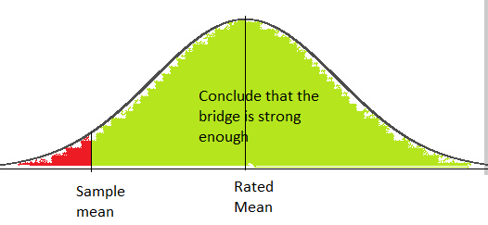

* 1. If we take the 2nd null hypothesis we will reject the null hypothesis that the bridge is weak only when our sample mean is higher than the rated mean by a certain value determined by the Confidence interval. Hence our acceptance and rejection region is as follows:

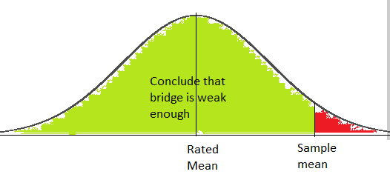

Thus we can see that we only accept the fact that bridge is strong enough with more stringent condition on the 2nd hypothesis. This will ensure safety of the public as the sample mean has to be higher than the rated mean by the amount determined by the Confidence interval. This is also a great proof that the second hypothesis is more stringent in terms of public safety.

1. Use different values for α (Type I error). You may consider 0.05, 0.01, 0.005 and 0.001 for the purpose of calculating the rejection region
2. There are 6 spans in the bridge. There were 6 measurements in each span. Test the above null hypothesis based on a sample mean of 87.43 kips and a sample variance of 42.25 kips2.

|  |  |  |  |  |  |
| --- | --- | --- | --- | --- | --- |
|  |  | **Constants** | |  |  |
|  |  | Sample mean | 87.43 |  |  |
|  |  | Sample variance | 42.25 |  |  |
|  |  | Sample std. dev. | 6.5 |  |  |
|  |  | Rated mean | 87 |  |  |
|  |  | Number of samples | 36 |  |  |
| **Null Hypothesis choice 1** | | Std. dev. Of sample means | 1.083333 | **Null Hypothesis choice 2** | |
| **LL of Sample mean** | **UL of Sample mean** | **Error tolerances (α)** | **t values** | **LL of Sample mean** | **UL of Sample mean** |
| 85.16962984 | inf | 0.05 | 1.689572 | - inf | 88.83037016 |
| 84.35913391 | inf | 0.01 | 2.437723 | - inf | 89.64086609 |
| 84.04921061 | inf | 0.005 | 2.723806 | - inf | 89.95078939 |
| 83.3816177 | inf | 0.001 | 3.340045 | - inf | 90.6183823 |
| **Implication:** As we see that increasing the confidence interval we are increasing the acceptance region of the bridge to be safe for travel. This thereby is favoring the contractor and risking public safety. There is a risk of commiting type 2 error where we due to our sample mean (might be a messed up sample) we are concluding bridge is safe to use while it is not will cause public life damage | |  |  | **Implication:** As we see that increasing the confidence interval we are increasing the strictness of the our acceptance region of the bridge to be safe for travel. This thereby ensuring that the bridge is safe for use if and only if our sample mean crosses the calculated thresholds. Hence we are decreasing the acceptance region by increasing confidence. | |
|  |  |
|  |  |
|  |  |
|  |  |
|  |  |
|  |  |
|  |  |

1. Decide whether you would recommend payment to KKICL based on the above hypothesis test.

Since sample mean is < our stringent cutoff hence no payment will be given to the contractor.

1. Calculate the p-value based on the sample mean and sample variance given above.

Here we have to calculate the P value of the right tail as below:

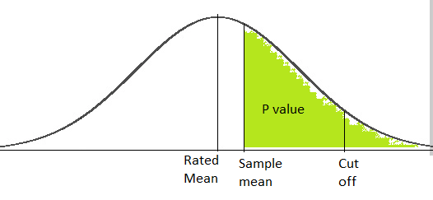

tx = = = 0.397

df = 35

Thus p value = T.DIST.RT(0.397,35) = 0.347

|  |  |
| --- | --- |
| **Sample t value** | **Sample p value** |
| 0.396923077 | 0.346917 |

**Appendix**

The test using deflectometers is non-destructive evaluation to determine the extent of flaws and load testing to assess the structural capacity of a bridge.

Through field testing, deflections of the bridge under different truck loads were recorded. During various stages of testing, the truck was left empty, partially loaded, or fully loaded. Normalized deflections under the truckloads were used to determine if there was a linear relationship between load and displacement. Using the truck’s weight and dimensions, the applied moment was calculated and compared to the theoretical nominal moment capacity of the bridge. The recorded deflections were used to determine the dynamic load allowance of the bridge.

The sensors were calibrated to the nearest 0.003 in. Deflection sensors, were placed on the bridge at mid-span of the span corresponding to test lanes. The deflectometers were bolted to anchors in the concrete through the sensor’s base plate. The deflectometers were pre-deflected approximately 0.75 in to allow for relaxation in the deflectometers as the slab displaced downward. The sensors were connected through separate channels to the data acquisition system.

Three test lanes were used to orient the truck on the bridge. Test Lane 1 was on the southern or downstream side of the bridge. The outermost wheel line was located 1 ft from the base of the parapet. This lane orientation is to coincide with the design lane for a slab beam which calls for a wheel line 1 ft from face of curb. Three deflectometers were located under this lane, one at the center of each wheel line and one corresponding to the center of the truck. Test Lane 2 was located on the upstream side of the bridge. The outermost wheel line was also located 1 ft off the base of the upstream side curb. One deflectometer was located under the outer most wheel line. Test Lane 3 was along the centerline of the bridge; with the wheel lines located 3 ft 6 in off either side of the centerline. Two deflectometers were situated on this lane.

See the figures below for further understating of the procedure.



**Deflectometer place under the bridge**

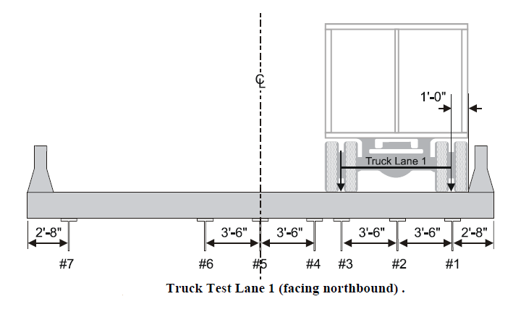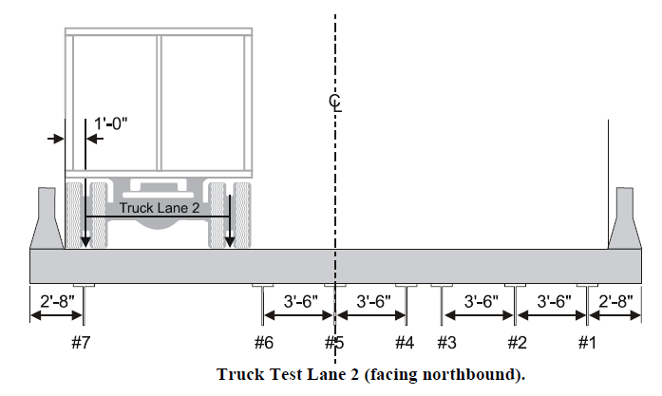

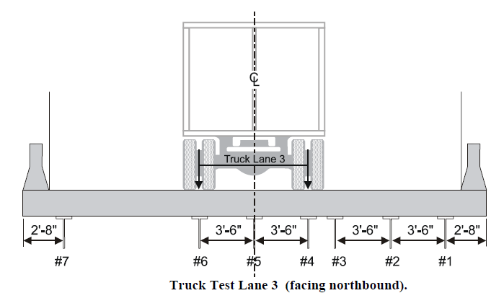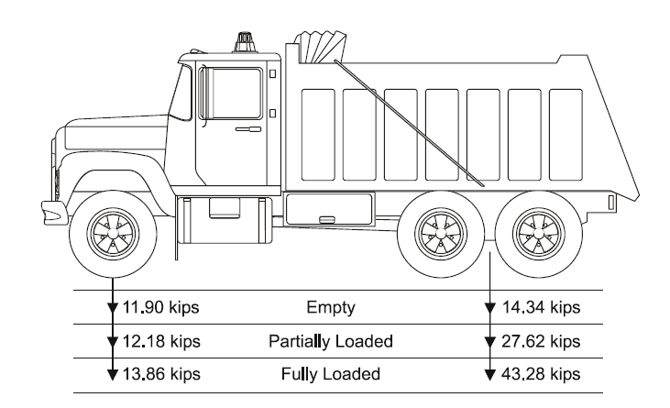

**Truck Load Design**

# Setting up the Null Hypothesis correctly

**What should be H0?**

**If null hypothesis is such that bridge is good enough we are favouring the contractor. Following will be the quadrants of operation.**

|  |  |  |
| --- | --- | --- |
|  | **H0** | **H1** |
|  | **Bridge KIPS ≥ threshold** | **Bridge KIPS < threshold** |
| **Conclude that Bridge KIPS ≥ threshold** | Not enough evidence to reject H0 | Accept H1 commit Type II error. Result allow traffic, bridge collapse and loss of lives. Probability = β. |
| **Conclude that Bridge KIPS < threshold** | Reject H0 commit Type I error. Result ask the contractor to strengthen the bridge more. Unncessary cost. Probability = α. | Disallow traffic. |

Notice here:

1. We have already studied that we have control over α by pushing it down to as low value as we want. Here the implication of making the type I error is paying more to the contractor.
2. We have less control over β. If β is high over the set α implication is loss of lives. This has a higher implication. So we want to keep α down as it has severe impact.

**If null hypothesis is such that bridge is not good enough we are favouring the people’s lives.**

See the quadrants of operation as below:

|  |  |  |
| --- | --- | --- |
|  | **H0** | **H1** |
|  | **Bridge KIPS ≤ threshold** | **Bridge KIPS > threshold** |
| **Conclude that Bridge KIPS ≤ threshold** | Not enough evidence to reject H0 | Accept H1 commit Type II error. Result ask the contractor to strengthen the bridge more. Unnecessary cost. Probability = β. |
| **Conclude that Bridge KIPS > threshold** | Reject H0 commit Type I error. Result allow traffic bridge collapse loss of lives. Probability = α. | Reject H0 and pay the contractor. |

We should want to be in a position to reject the null hypothesis. If we set up null hypothesis is such that bridge is not good enough, α = probability of the error that we judge the bridge is good even though its not good. β = probability that we judge the bridge

1. Vishnuprasad Nagadevara, Indian Institute of Management Bangalore,

   Based on the Report, “Structural Load Testing and Flexure Analysis of The Route 701 Bridge in Louisa County, Virginia”, Jeremy Lucas et. al., Virginia Transportation Research Council, Charlottesville, Virginia, June 2004